**Computer Research**

**Name:** Mahmoud Emad Ahmed Emam.

**Edu mail**: [mahmoud195956@feng.bu.edu.eg](mailto:mahmoud195956@feng.bu.edu.eg).

**B.N**: 856.

**Date:** 4/6/2020

**Topic:** programming languages.

**Examiners committee**

|  |  |  |
| --- | --- | --- |
| 1 | Dr. Ahmed Bayoumi |  |
| 2 | Dr. Shady Elmashad |  |
| 3 | Dr. Abdelhamid Attaby |  |

**Abstract to project**

I chose this topic to recognize more about programming languages. A programming language is a vocabulary and set of grammatical rules for instruction to perform specific tasks on a computer or computing device. The word programming language typically refers to languages of the highest level, such as BASIC, C, C++, COBOL, Java, FORTRAN, Ada and Pascal. Every programming language includes a specific collection of keywords (words it understands) and a special syntax for program organization.

**Screenshots:**

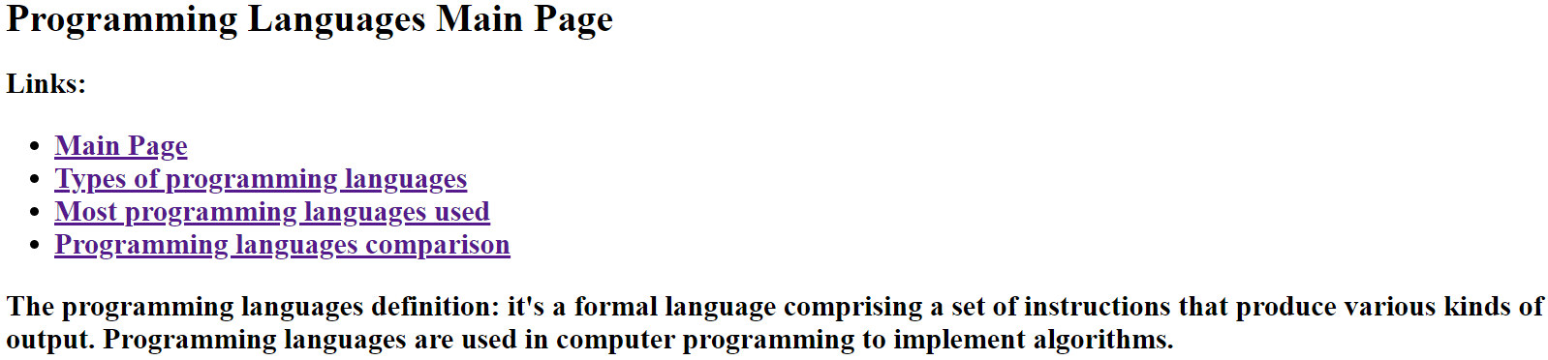

**Source code**

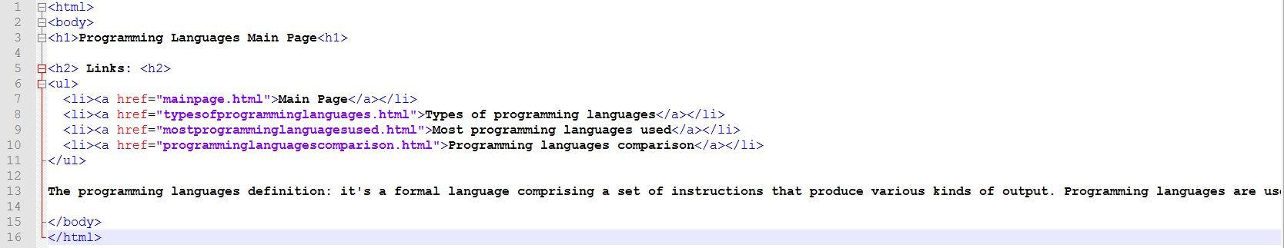

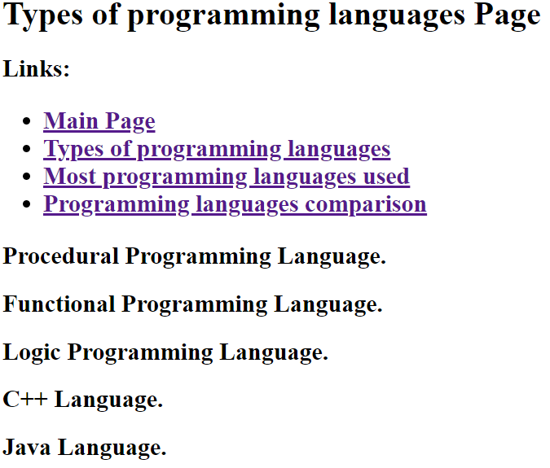

**Source code**

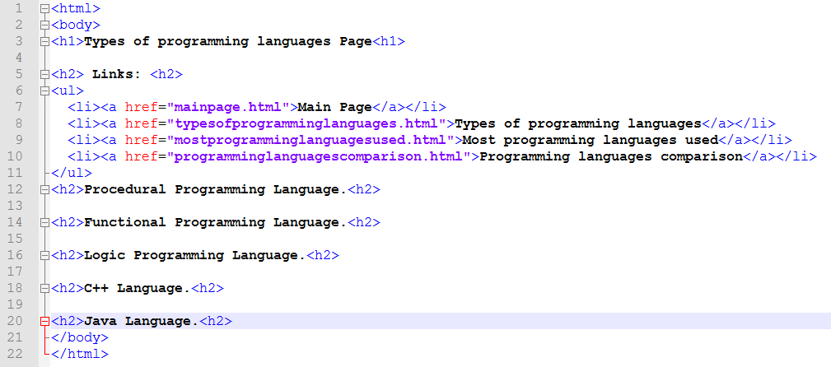

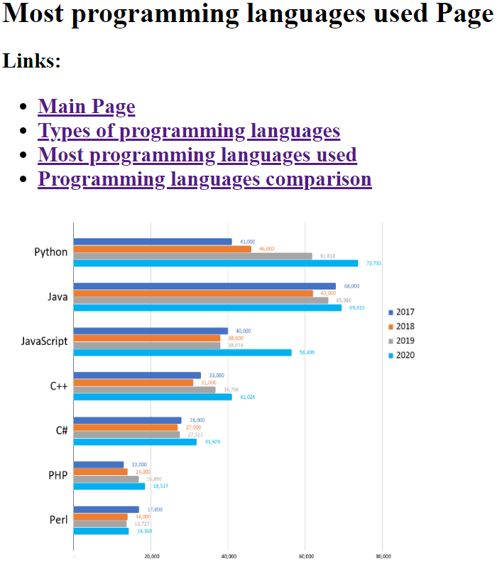

**Source code**

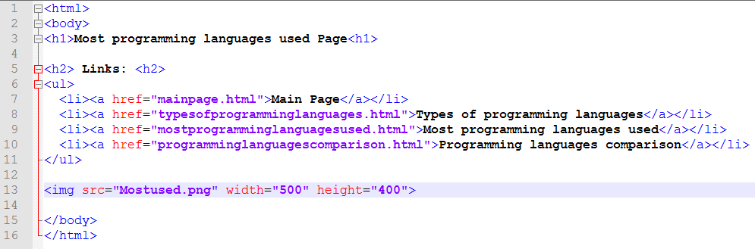

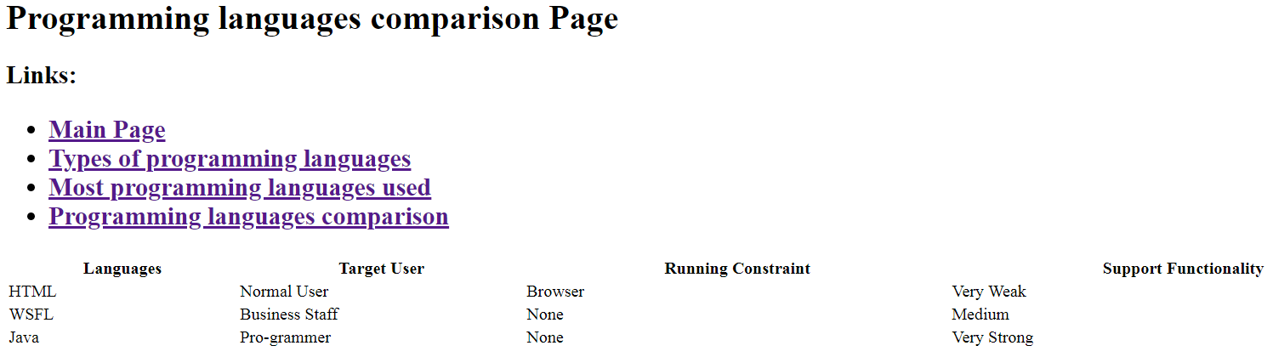

**Source code**

